Experiment Number : 8 Date: 25/02/2026

Implementation of Packages in Java

Aim:
Write a Java program to implement built-in, user-defined packages and accessing all classes in a package.

PRE LAB EXERCISE
QUESTIONS
- What is java.util package and what collection framework does it contain?

java.util is a built-in Java package that provides utility classes and the Collection Framework for storing and manipulating data.
It contains:
- List → ArrayList, LinkedList
- Set → HashSet, TreeSet
- Queue → PriorityQueue
- Map → HashMap, TreeMap

- What are the two types of packages in Java?

The two types of packages in Java are:
- Built-in Packages
- User-defined Packages

IN LAB EXERCISE
Objective
To understand and implement the concepts of built-in, user-defined packages and accessing all classes in a package in Java.
Built-in Packages comprise a large number of classes that are part of the Java API. Some of the commonly used built-in packages are:
- java.lang: Contains language support classes(e.g, classes that define primitive data types, math operations). This package is automatically imported.
- java.io: Contains classes for supporting input/output operations.
- java.util: Contains utility classes that implement data structures such as Linked Lists and Dictionaries, as well as support for date and time operations.
- java.applet: Contains classes for creating Applets.
- java.awt: Contains classes for implementing the components for graphical user interfaces (like buttons, menus, etc).
Source Code
import java.util.Random; // built-in package
public class Sample{
public static void main(String[] args) {
// using Random class
Random rand = new Random();
// generates a number between 0–99
int number = rand.nextInt(100);
System.out.println("Random number: " + number);
}
}

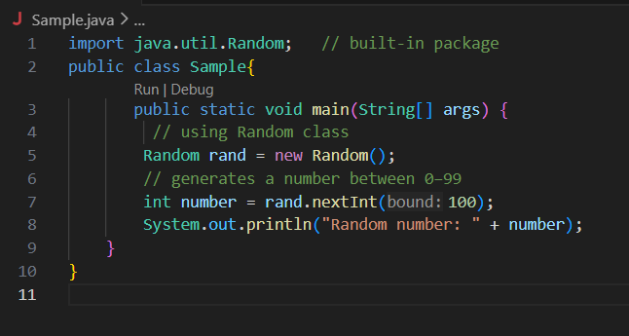
Output
Random number: 49


User-defined Packages are the packages that are defined by the user.
Source code
package com.myapp;
public class Helper {
public static void show() {
System.out.println("Hello from Helper!");
}
}
==To use this in another class==
import com.myapp.Helper;
public class Test {
public static void main(String[] args) {
Helper.show();
}
}
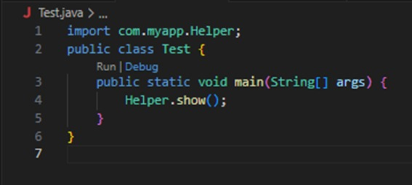
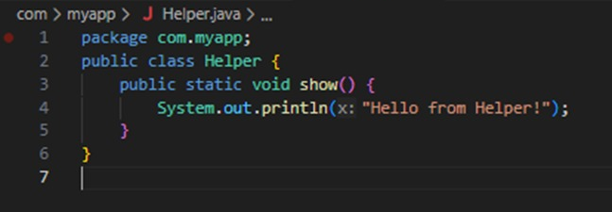

Output:
Hello from Helper!



//Importing all classes from a package.
Source code
import java.util.Vector;
public class Coders {
public Coders() {
// java.util.Vector is imported, We are able to access it directly in our code.
Vector v = new Vector();
java.util.ArrayList l = new java.util.ArrayList();
l.add(3);
l.add(5);
l.add(7);
System.out.println(l);
}
public static void main(String[] args) {
new Coders();
}
}
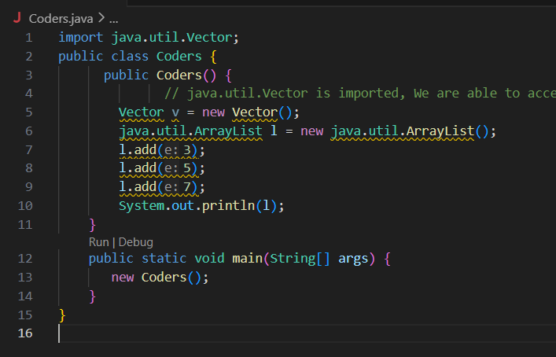
Output
[3,5,7]
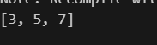
POST LAB EXERCISE
- What will happen if two classes in different packages have the same name and are imported in a Java file?

If two classes with the same name from different packages are imported, Java will show a compile-time ambiguity error because it cannot decide which class to use.
Solution:
Use the fully qualified class name (complete package path).

- What is the purpose of using packages in Java?

Packages are used to:
- Organize large programs properly
- Avoid class name conflicts
- Improve code reusability
- Provide security (access control)
- Make maintenance easier

- Which built-in Java package would you use if you want to create a GUI window and display a message?
- java.util
- java.sql
- java.awt
- java.net

C. java.awt
Reason (brief):
java.awt provides classes to create GUI components like windows, buttons, labels, and dialogs.

ASSESSMENT

Description | Max Marks | Marks Awarded
Pre Lab Exercise | 5
In Lab Exercise | 10
Post Lab Exercise | 5
Viva | 10
Total | 30
Faculty Signature

